Please read the power point it gives the context and the steps that we followed to get everything work.

You have to install linx, visa, and LabVIEW

Link:

<http://sine.ni.com/nips/cds/view/p/lang/en/nid/212478> //linx

<http://www.ni.com/download/ni-visa-18.0/7597/en/> //visa for labview 2018

for more detail visit this website:

<https://www.labviewmakerhub.com/doku.php?id=learn:tutorials:libraries:linx:getting_started>

after you have to put the COM in serial port corresponding to the card that you interfaced

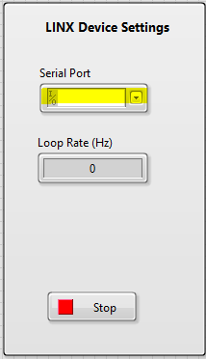

According to the function described in the power point we have used those parts and components

If you want to do the same project as us so, all you have to do to change the zeros in this picture with the pin that you related to the corresponding component

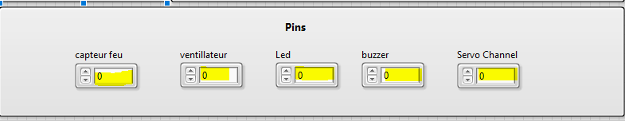

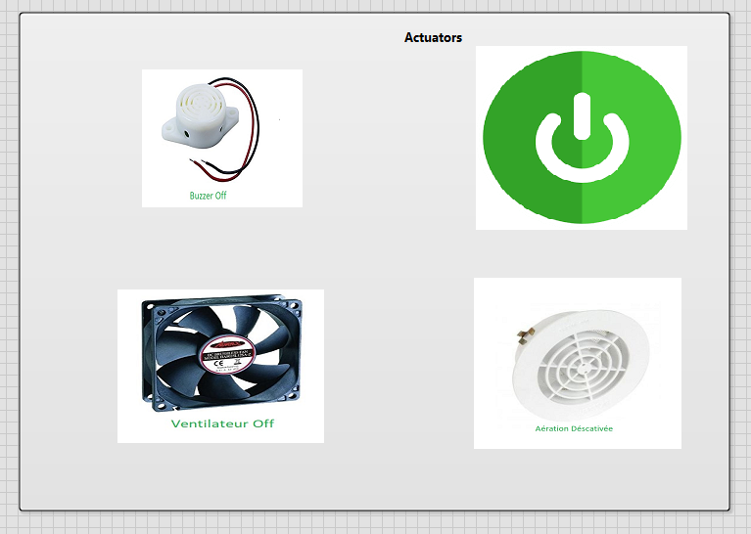

Those actuators changed with the condition and the values of the sensor of fire (we used it in place of gas sensor).

Hope that you enjoy the reading of the presentation and you improve what we done and thank you if you want to ask any question I’ll be there for you